SQL Query: -

1.Create a Database

CREATE DATABASE DBPROJECT;

2. Create a table ‘PLAYINGPOSITION’ (We created this table first because this is used as a referencing table)

Since playingposition is a multivalued attribute to an entity ‘PLAYER’ in our EER diagram. Created a relation ‘PLAYINGPOSITION’, where playingposition is a multivalued attribute.

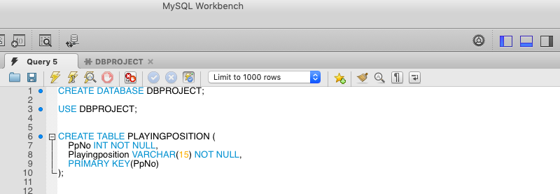

CREATE TABLE PLAYINGPOSITION (

PpNo INT NOT NULL,

Playingposition VARCHAR(15) NOT NULL,

PRIMARY KEY(PpNo)

);

2.Create a table ‘Groups’

This table was created to differentiate all the groups present in the match (groups belong to Groupgame and knockoutgame). This table is used as reference to ‘GROUP_COUNTRY’ table in our database.

CREATE TABLE GROUPS (

id INT NOT NULL,

Group_name VARCHAR(15) NOT NULL,

PRIMARY KEY(id)

);

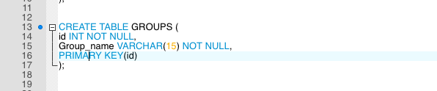

3. Create a Table ‘STADIUM’

This table is used as a reference to ‘GAME’ Table because matches are played in stadium.

Create table STADIUM(

Sid INT NOT NULL,

SName VARCHAR (15),

City VARCHAR (15),

Capacity int,

PRIMARY KEY(Sid)

);

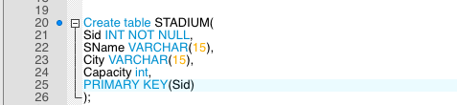

4.Create a table GAME/MATCH

This table uses attribute ‘Gid’ (surrogate key)as a primary key and attribute ‘stadium_id’ is used as a foreign key which is referencing the table ‘STADIUM’

Create table GAME(

Gid INT NOT NULL,

GType VARCHAR(15),

Gdate INT,

Stadium_id INT NOT NULL,

Team1 VARCHAR(15),

Team2 VARCHAR(15),

Team1_Score INT,

Team2_Score INT,

PRIMARY KEY(Gid),

FOREIGN KEY(Stadium_id) REFERENCES STADIUM(Sid)

);

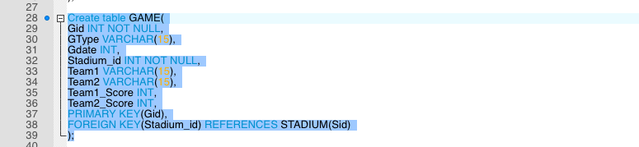

5. CREATE TABLE ‘TEAM’

This table has an attribute ‘cid’(surrogate key) as a primary key and attribute ‘CName’ is set as unique and uses ‘Gid’ as a foreign key referencing the table GAME.

Create table TEAM(

CName INT NOT NULL,

Continent VARCHAR(15),

Confederation VARCHAR(15),

Population INT,

Cid INT NOT NULL,

Gid INT NOT NULL,

UNIQUE(CName),

PRIMARY KEY(Cid),

FOREIGN KEY(Gid) REFERENCES GAME(Gid)

);

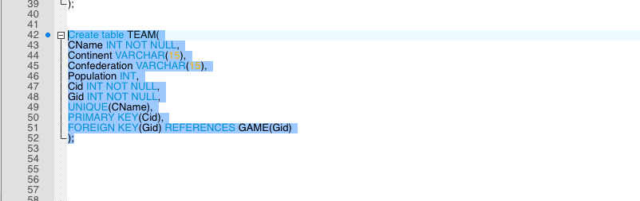

6. CREATE TABLE ‘GROUP_COUNTRY’

This table is the mapping between country and groups to identify which table belongs to which group.

This table has an attribute ‘GNo’as a primary key and uses ‘id’ as a foreign key referencing the ‘GROUPS’ table .

CREATE TABLE GROUP_COUNTRY (

GNo INT NOT NULL,

Cname VARCHAR(15) NOT NULL,

id INT NOT NULL,

PRIMARY KEY(GNo),

FOREIGN KEY(id) REFERENCES GROUPS(id)

);

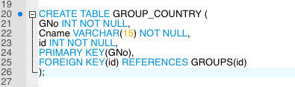

6. CREATE TABLE ‘PLAYER’

This table has an attribute ‘PNo’ as a primary key and uses ‘PpNo’ as a foreign key referencing the ‘PLAYINGPOSITION’ table .

Create table PLAYER(

PNo INT NOT NULL,

CName VARCHAR(15),

Fname VARCHAR(15),

Mname INT NOT NULL,

Jname VARCHAR(15),

JNo INT,

BirthDate INT,

Club VARCHAR(15),

Height INT,

Weight INT,

Substitute_PNo INT,

Substitution_time INT,

PpNo INT,

PRIMARY KEY(PNo),

FOREIGN KEY(PpNo) REFERENCES PLAYINGPOSITION(PpNo)

);

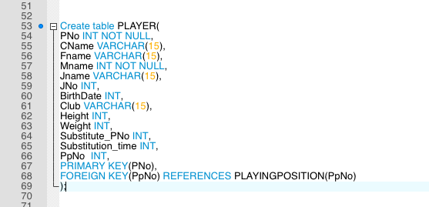

CREATE TABLE ‘GROUP_GAME’

This table has a attribute ‘Gid’ set as a foreign key referencing the ‘GAME’ table .This entity is a subclass of a ‘GAME’ Entity.

Create table GROUP_GAME(

Gid INT NOT NULL,

PRIMARY KEY(Gid),

FOREIGN KEY(Gid) REFERENCES GAME(Gid)

);

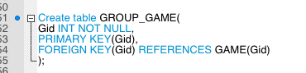

CREATE TABLE ‘KNOCKOUT_GAME’

This table has a attribute ‘Gid’ set as a foreign key referencing the ‘GAME’ table .This entity is a subclass of a ‘GAME’ Entity.

Create table KNOCK_OUT(

Gid INT NOT NULL,

Knockout_time INT,

PRIMARY KEY(Gid),

FOREIGN KEY(Gid) REFERENCES GAME(Gid)

);

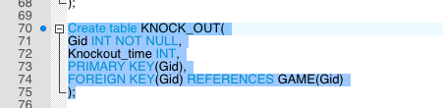

CREATE TABLE ‘REGULAR’

This table has a attribute ‘Gid’ set as a foreign key referencing the ‘KNOCK_OUT’ table .This entity is a subclass of a ‘KNOCK_OUT’ Entity.

Create table REGULAR(

Gid INT NOT NULL,

PRIMARY KEY(Gid),

FOREIGN KEY(Gid) REFERENCES KNOCK_OUT(Gid)

);

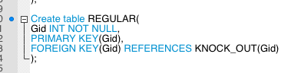

CREATE TABLE ‘EXTRA’

This table has a attribute ‘Gid’ set as a foreign key referencing the ‘KNOCK_OUT’ table .This entity is a subclass of a ‘KNOCK_OUT’ Entity.

Create table EXTRA(

Gid INT NOT NULL,

PRIMARY KEY(Gid),

FOREIGN KEY(Gid) REFERENCES KNOCK_OUT(Gid)

);

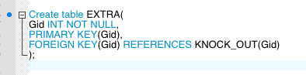

CREATE TABLE ‘PENALTY’

This table has a attribute ‘Gid’ set as a foreign key referencing the ‘KNOCK_OUT’ table .This entity is a subclass of a ‘KNOCK_OUT’ Entity.

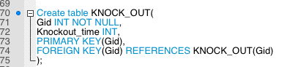

Create table PENALTY(

Gid INT NOT NULL,

PRIMARY KEY(Gid),

FOREIGN KEY(Gid) REFERENCES KNOCK_OUT(Gid)

);

CREATE TABLE ‘MATCH_RESULTS’

This table keeps the final winner information along with the points scored by Team1 and Team2. We used Attribute ‘Team1_Points’ and ‘Team2_Points’ here because as mentioned in the requirement ‘GROUP_GAME’ has a draw match. In a match team wins winning team gets 2 points and a losing team doesn’t get any point. But if it’s a draw match then both the teams get 1 point each. So it’s easier to determine a winner with points specially in these case.

Create table MATCH_RESULTS(

M_id INT NOT NULL,

Gid INT NOT NULL,

Team1_Points INT NOT NULL,

Team2_Points INT NOT NULL,

PRIMARY KEY(M_id),

FOREIGN KEY(Gid) REFERENCES GAME(Gid)

);

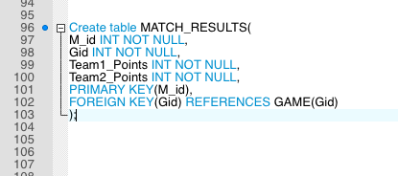

CREATE TABLE ‘CARDS’

Since playingposition is a multivalued attribute to an entity ‘PLAYER’ in our EER diagram. Created a relation ‘PLAYINGPOSITION’, where playingposition is a multivalued attribute.

CREATE TABLE CARDS (

Card_id INT NOT NULL,

Ctype VARCHAR(15) NOT NULL,

PRIMARY KEY(Card_id )

);

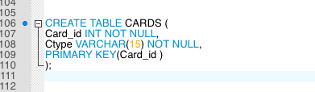

CREATE TABLE ‘GOALS’

Since playingposition is a multivalued attribute to an entity ‘PLAYER’ in our EER diagram. Created a relation ‘PLAYINGPOSITION’, where playingposition is a multivalued attribute.

CREATE TABLE GOALS (

Goal_id INT NOT NULL,

Goal_Type VARCHAR(15) NOT NULL,

PRIMARY KEY(Goal_id)

);

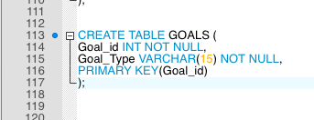

Create table PLAYER_MATCH(

Player_match_id INT NOT NULL,

PNo INT NOT NULL,

Gid INT NOT NULL,

Total_Goals_scored INT NOT NULL,

Total_cards_recieved INT NOT NULL,

PRIMARY KEY(Player_match_id ),

FOREIGN KEY(PNo) REFERENCES PLAYER(PNo),

FOREIGN KEY(Gid) REFERENCES GAME(Gid)

);

